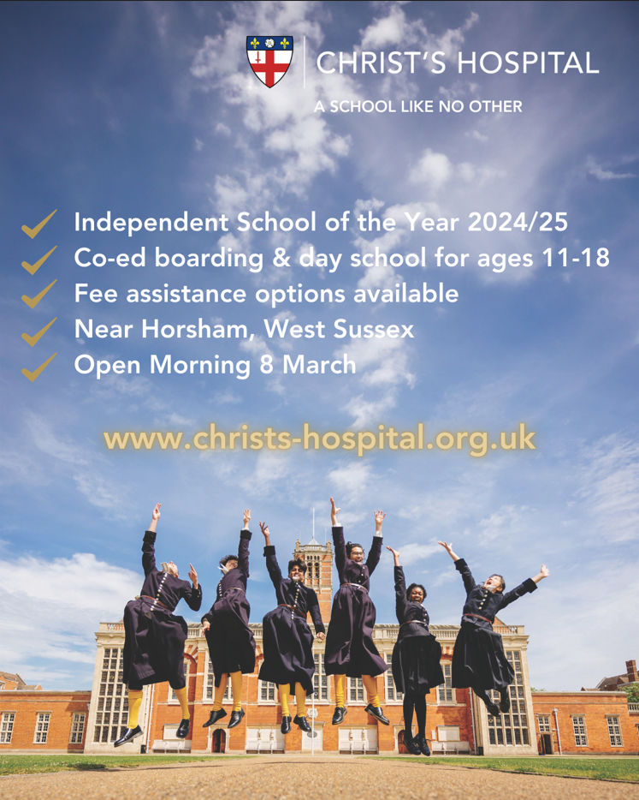

We warmly invite all families who might be considering a secondary education at Christ’s Hospital to our Open Morning on Saturday 8 March 2025.

Christ’s Hospital’s unique foundation allows us to offer families (day and boarding) the potential of fee assisted places in the form of bursaries and/or scholarships.
Our means-tested bursaries are granted to 650 of our 900 pupils.
To book now sign up here > Book an open morning - Christ's Hospital
Christ’s Hospital
01403 246555
Hello@christs-hospital.org.uk

